**620574-EPP-1-2020-1-NO-EPPKA3-VET-COVE Erasmus+ Center of Vocational Excellence** **bridges.eu**

**Deliverable: D10.4**

**Vocational and Educational Exhibition Trade Fair**

**________________________________________**

**WP 10: Implementation – VET responsiveness towards industry needs**

**WP Leader: BCC**

**Contributor: GG**

Fig 1. Daniel Krång presents the Bridges project



The European Commission support for the production of this publication does not constitute endorsement of the contents which reflects the views only of the authors, and the Commission cannot be held responsible for any use which may be made of the information contained therein.

**Participated at Gullmars ExPo at Gullmarsgymnasiet, Mars 21:st 2024**

**Background:**

Gullmars ExPo is an educational and vocational trade fair which is held annually in Lysekil, Sweden. The target group is young adults finishing their gymnasium studies. It is a fair where employers and future competence meets.

The main targets are to:

* Inspire future competences for future choices
* Improve the school´s cooperation with the local and regional business community
* Create awareness of local and regional business
* Promote the supply of skills

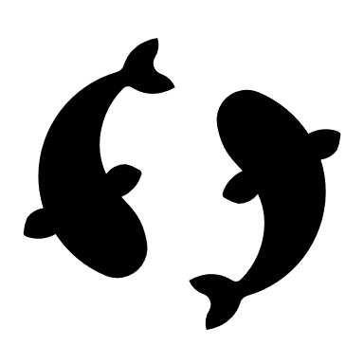

**B**ridges was presented at the trade fair with our roll-up. The main goal was to present ourselves show a link between company needs and future competence. We talked a lot with youngsters and companies who were curious about Bridges, what we do and how we work.

Fig 2. Daniel Krång presents the Bridges project

Outcomes:

The presentation of Bridges was good. We achieved our goals and made a lot of contact with students and local/regional companies. The awareness of the Bridges project is after this much more spread.

We might even have inspired some students to start educating themselves in the field of fish farming.



**COPYRIGHT**

©Copyright 2020-2024 the Bridges Consortium, consisting of:

* Trøndelag County Authority (TC), Norway
* Gullmarsgymnasiet/Lysekils Vuxenutbildning (GG), Sweden
* Peimari Group for Further Education and Training (Livia), Finland
* Icelandic College of Fisheries (ICF), Iceland
* Holar University (Holar), Iceland
* University of Akureyri (Akureyri), Iceland
* SalMar Farming (Salmar), Norway
* Arnarlax (Arnarlax), Iceland
* Nordic Trout (NT), Finland
* Nordic Trout Sweden (NTS), Sweden
* Blue Competence Centre (BCC), Norway
* Easy Learning Solutions (ELS), Norway

This document may not be copied, reproduced or modified in whole or in part for any purpose without written permission from the Bridges Consortium. In addition to such written permission to copy, reproduce or modify this document in whole or part, an acknowledgement from the authors of the document and all applicable portions of the copyright notice must be clearly referenced.

All rights reserved.

This document may be updated if needed and changed without notice.**



The European Commission support for the production of this publication does not constitute endorsement of the contents which reflects the views only of the authors, and the Commission cannot be held responsible for any use which may be made of the information contained therein.