620574-EPP-1-2020-1-NO-EPPKA3-VET-COVE Erasmus+ Center of Vocational Excellence bridges.eu

D10.4 – Vocational and education exhibition trade fair, SWE

WP 10 - Implementation VET responsiveness towards industry needs

WP Leader: BCC

Contributors: GG

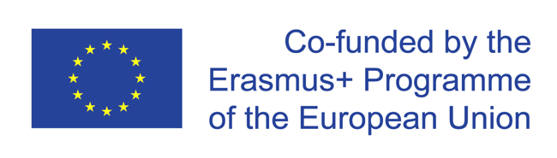
The European Commission support for the production of this publication does not constitute endorsement of the contents which reflects the views only of the authors, and the Commission cannot be held responsible for any use which may be made of the information contained therein.
Trade fair, Sweden
Gullmarsgymnasiet had four students and one teacher representing the marine education at the high school fair in Gothenburg 8-10 November 2022. On this trade fair we presented the aquaculture training and the bridges project. In total there were 20,726 visitors on these three days, mostly 9th graders who will make their high school choice. We had many people come to our booth and were interested in coming and checking out the school (open house on December 3).
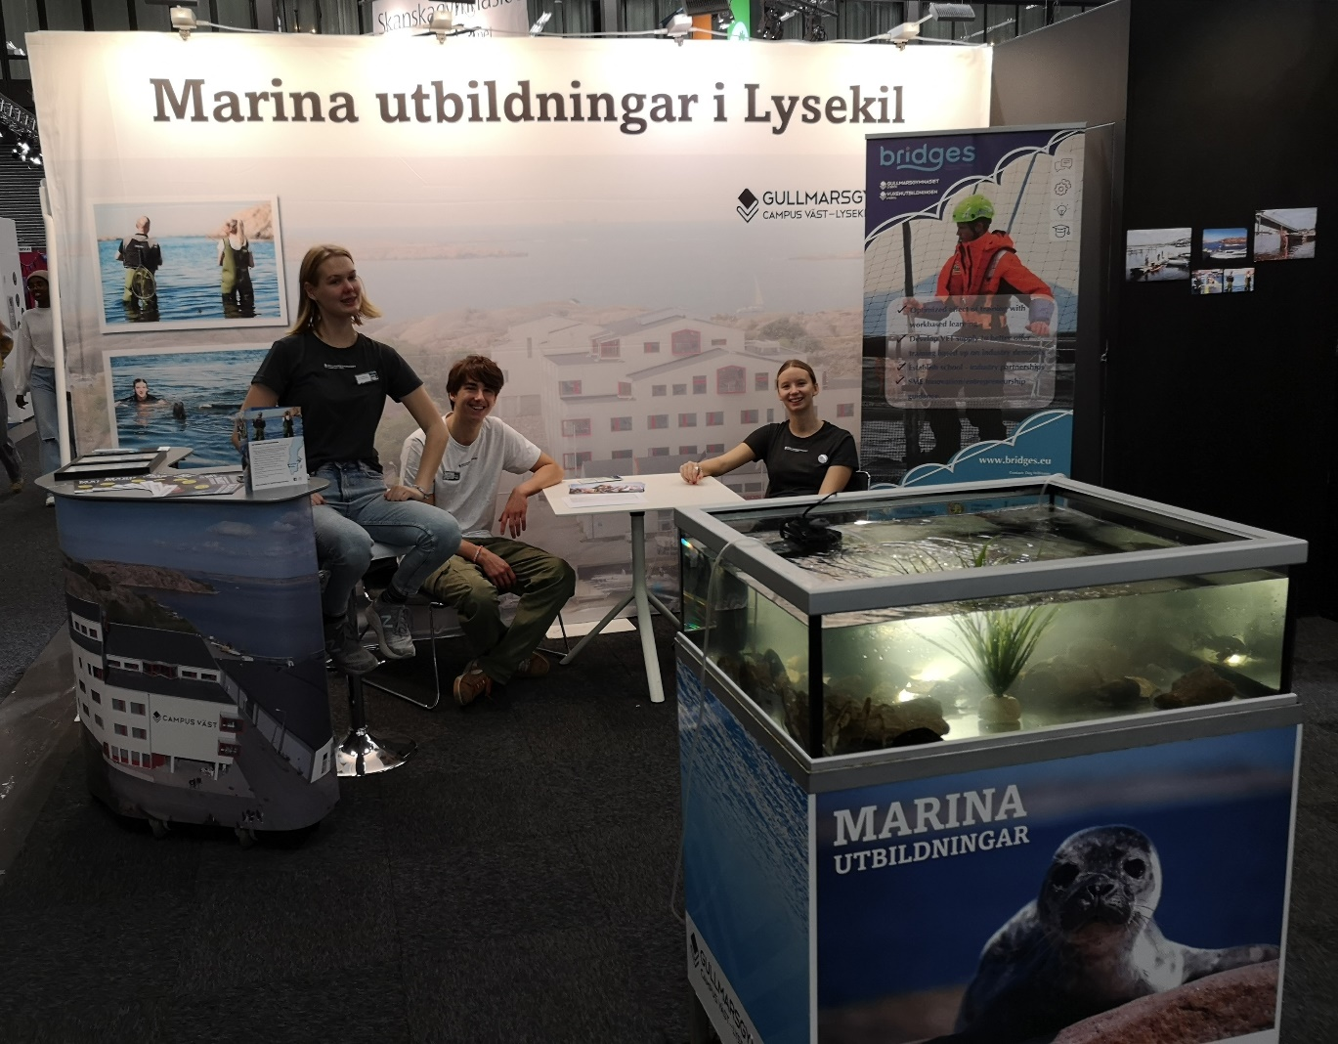Picture 1: our stand at the Gothenburg fair

Gullmarsgymnasiet also participated in the Stockholms digital trade fair, where students and teachers remotely were shown our premises and talked about the aquaculture training. In total there were 18 787 visitors on these two days and around 100 talked to our students.

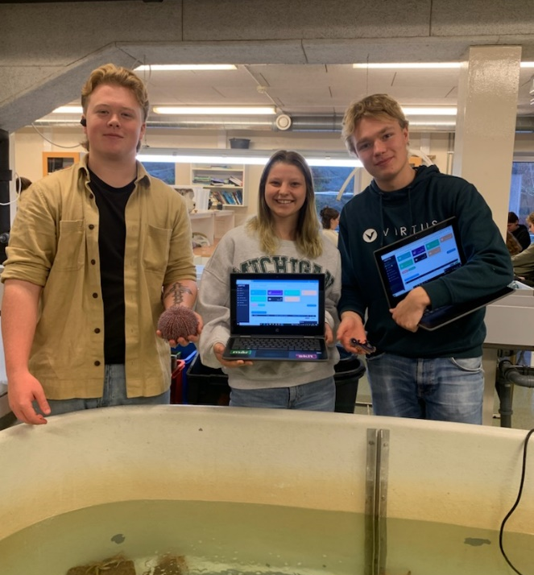
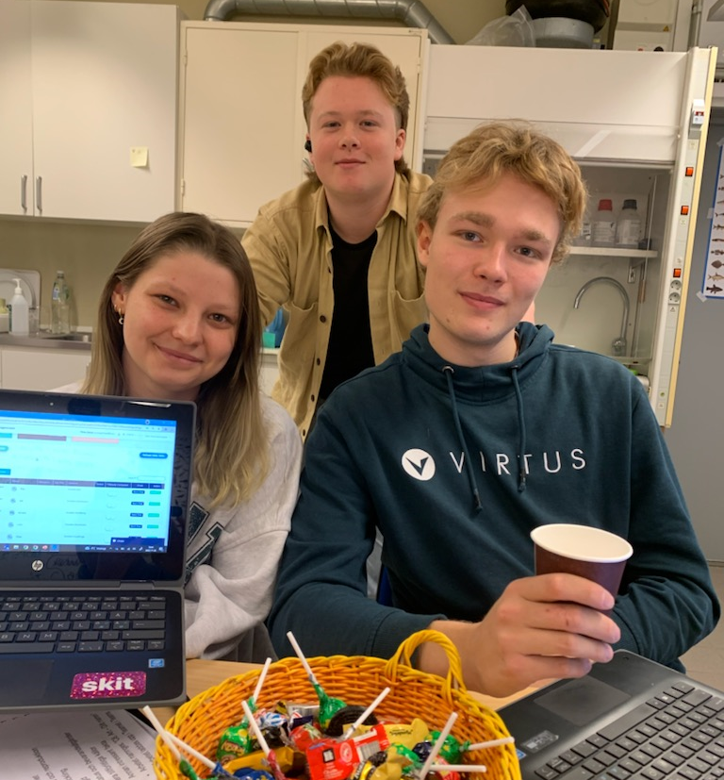
Picture 2: our students chatting with Picture 3: The students showed our schools premises
participants at the fair

COPYRIGHT
©Copyright 2020-2024 the Bridges Consortium, consisting of:
- Trøndelag County Authority (TC), Norway
- Gullmarsgymnasiet/Lysekils Vuxenutbildning (GG), Sweden
- Peimari Group for Further Education and Training (Livia), Finland
- Icelandic College of Fisheries (ICF), Iceland
- Holar University (Holar), Iceland
- University of Akureyri (Akureyri), Iceland
- SalMar Farming (Salmar), Norway
- Arnarlax (Arnarlax), Iceland
- Nordic Trout (NT), Finland
- Nordic Trout Sweden (NTS), Sweden
- Blue Competence Centre (BCC), Norway
- Easy Learning Solutions (ELS), Norway

This document may not be copied, reproduced or modified in whole or in part for any purpose without written permission from the Bridges Consortium. In addition to such written permission to copy, reproduce or modify this document in whole or part, an acknowledgement from the authors of the document and all applicable portions of the copyright notice must be clearly referenced.
All rights reserved.
This document may be updated if needed and changed without notice.

Contact: Dag Willmann
dagwi@trondelagfylke.no

